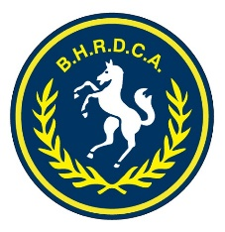 BHRDCA UMPIRE’S MATCH REPORT
Last updated Oct. 2023
 | v’s |  | Grade |  | Rnd

PLAYED AT |  | on |  | and

WON BY |  | by

Time of start | 1st Day |  |  | 2nd Day
Time of finish | 1st Day |  |  | 2nd Day

If late start, Club responsible & reason:
Over rates:

Team Name:
 | 1st innings | 2nd innings | 1st innings | 2nd innings
A: Actual batting time
B: On field time lost & allowances
C: Adjusted batting time (A-B)
D: Overs bowled (include uncompleted over as a full over)

Details of any over penalties:
State of Wicket & Ground:

Conduct of Players, Names of Players & Club Contravening any Rule, & Nature of Breach:
Yellow Card issued | Y/N | Player: | Club:
Red Card issued | Y/N | Player: | Club:
Complete this section with the relevant “Misconduct Report” form (MRF) and a Tribunal will be established if required.
(Use other side if necessary.)
General Remarks and Match Day Observations:

RMS, HWS & DMS Shield Grades Only BEST & FAIREST VOTES (please check spelling & print clearly)
Votes | FAMILY NAME | GIVEN NAMES | CLUB
3
2
1

Umpires’ Signatures (Print & Sign name): Date:

This report must reach Association Secretary by 8pm on Tuesday following completion of the match.

